# Errors while making the acceptance test.

1. As a guest the user cannot delet/edit events. (buttons in organe square should not appear when logged in as “guest”)

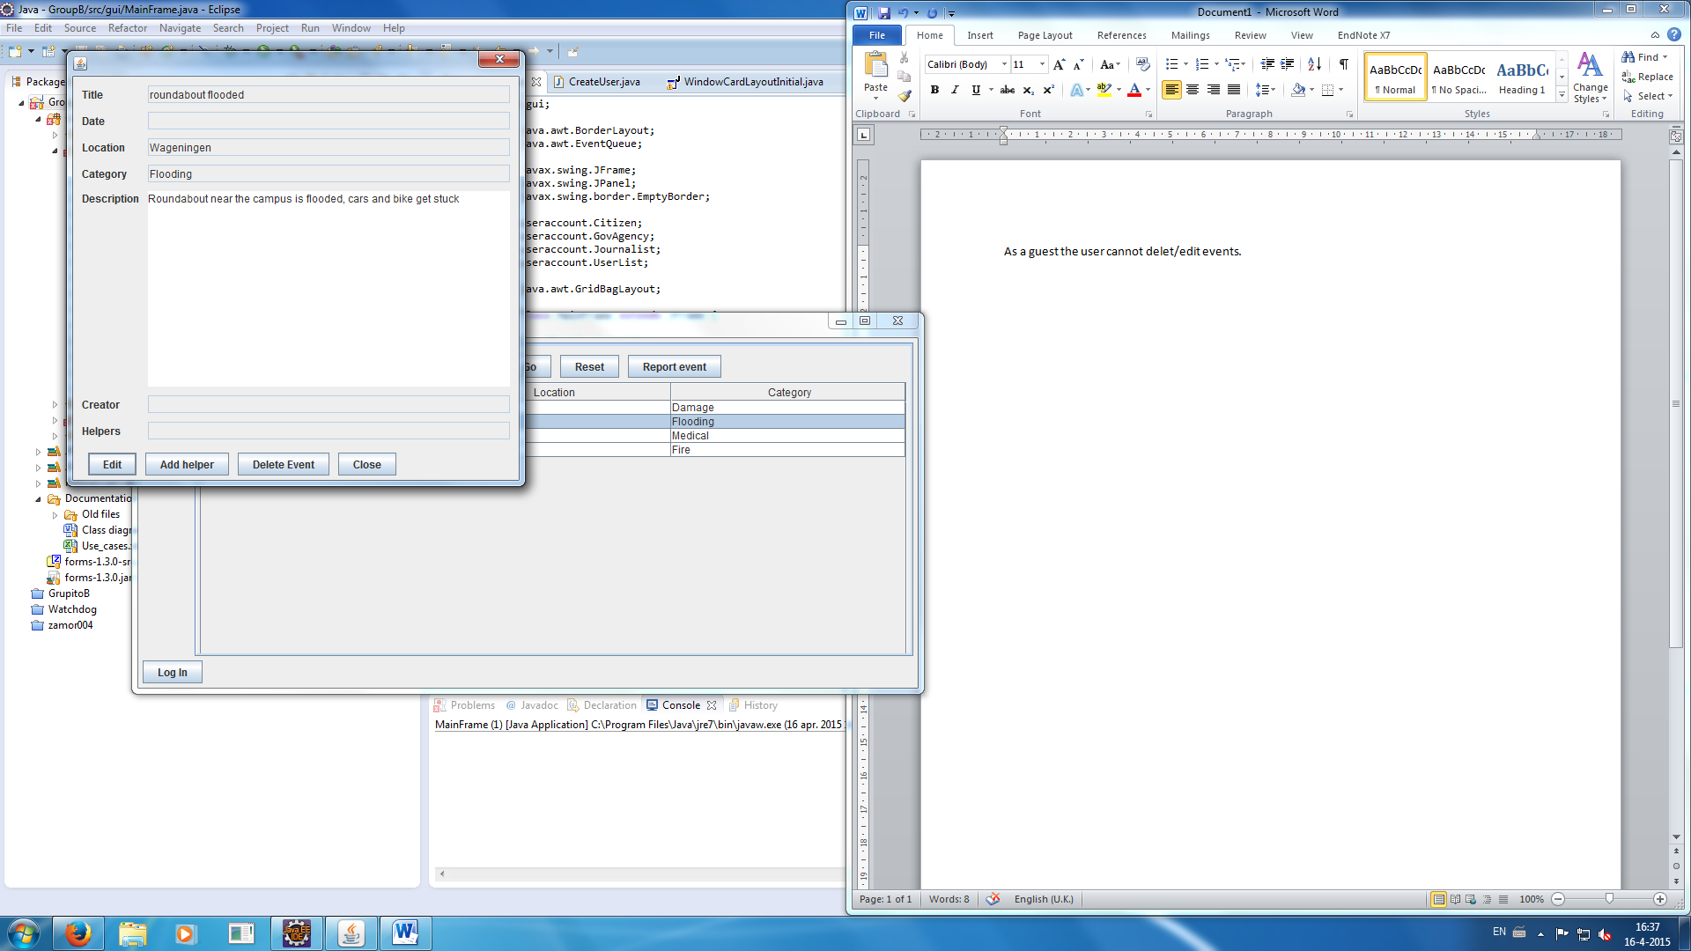

1. As a guest an user can’t report an event (only view).